Short Term and Long Term Stock Predictions using Machine Learning Models

IT489 Capstone: Project Final Report

School of Technology and Innovation, Marymount University

By Pravin Raja

May 5, 2021

Honor Pledge

“On my honor, I have neither given nor received aid on this assignment.”

Table of Contents

**Objective and Introduction** **3**

**Project Timeline** **4**

**Literature Review** **5**

**Methodology** **8**

System Architecture 9

System Architecture Processes Explained 9

**Results** **14**

Arima Results 14

LSTM Results: 17

Kafka & Back End Results 19

**Conclusion** **20**

**Attached Documents** **22**

**Project Tools Used** **28**

**Bibliography** **29**

**Final Documentation** **29**

# 

# Objective and Introduction

After the insane short squeeze of the stock of the American video game retailer GameStop (GME) that caused significant financial consequences for certain hedge funds and extensive losses for short sellers, there was an eager curiosity to study and predict future stock prices for other well known companies using open-source technologies that the average tech enthusiast could understand and work with according to their needs. The main goal of this project is to initialize and work with stock data sources to make long term and short term predictions by leveraging open-source technologies with the two main being Kafka for message queuing and the Python Jupyter Notebook to complete the streaming and batch processing to make accurate predictions of live time stock data using Yahoo Finance data and machine learning techniques. In this project there will be highlighting of various skill sets ranging from machine learning, data and financial engineering skills by working with concepts like ETL (Extract, Transform, and Load), data processing and cleansing, visualization, message queuing, financial modeling, implementing frameworks and algorithms, and model fitting. The end goal is to implement a real time project application to predict company stock prices and look at rising companies for the future. Everything in this project will be 100% open source and all data of publicly traded companies is sourced through Yahoo Finance.

For further information, this project is good for tech enthusiasts to work and play with, however it cannot be recommended to any clients like enterprises or small businesses mainly because of outliers in past histories or unpredictable outcomes like black-swan (extreme events) in the stock market. Secondly, some companies might have already bought an expensive and high level tool or service to use for this type of project. Finally, a big disclaimer that needs to be said is that the stock market can be extremely volatile at times and that investing into the stock market is a game of risk and reward, anybody wanting to make investments should always proceed with caution and should also know that they are solely responsible and liable for any good or bad outcomes that happens to them.

Special thanks to Dr.[Diane Murphy](mailto:dmurphy@marymount.edu)for helping advise this project and all the helpful knowledge gained throughout the years before graudation. Her robust skill sets and her knowledge of various technology stacks used in the corporate environment makes her a good fit to understand and advise this project. I will not be using any other faculty for help mainly due their schedules being filled up with other students and I am also pretty well versed in the field of Data Engineering, so I can expect to do this all by myself.

# Project Timeline

This is a long and tedious project task as we can see, I might be late on certain days, but I believe I can fully finish and present before May 1st. The building of the entire project and writing out the draft of the process took a lot of time, it was slightly late. Everything else was mostly on time before the final presentation. Overall, I believe that my time management for this project was very good considering the complexity.

|  |  |  |  |  |
| --- | --- | --- | --- | --- |
| Finish Date | Due Date | Task | Explanation | Effort Level Based on Finish Time(0-5) |
| 1/26 | 1/27 | Topic Research | Research topic and tools to use for projects. Get approval | 5: On Time |
| 2/17 | 2/17 | Work on Proposal | Complete all requirements based on syllabus and meeting two slides | 4: On Time |
| 2/17 | - | Self Research | Install all required software, gather data sources, setup test environment and libraries | On Track |
| 2/24 | 2/24 | Finish Lit. Review | Gather sources, citation, research methods, evaluate and summarize sources based on quality. Use meeting three slide as guide | 4: On Time |
| 3/12 | 3/10 | Research Progress and Proposal Final | Create a system architecture diagram and begin to  report progress and turn in the project proposal final. | 3: Slightly Late |
| 4/12 | 4/7 | Work on Project Draft | Complete all requirements based on school documents to complete full 16+ page document alongside working software application | 2: Late |
| 4/17 | 4/19 | Self Progress Check | Look to connect the pieces and put everything together | 4: Finished on time |
| 4/20 | 4/20 | Prepare Project Presentation | Integrate presentation and rehearse for potential questions. | 4: On Track |
| 4/21 | 4/21 | Complete Presentation | Prepare to present and showcase work | 5: On Track |
| 5/5 | 5/5 | Retrospective | Self- Reflection of completed work | 4 |
| 5/6 | 5/6 | Finish Line | Pat on back for getting this far. THE END | 5 |

# Literature Review

This literature review will address the references and research papers that will be important to the project of predicting stock prices using machine learning models . The references will explain three main concepts of different statistical methods for stock prediction, analysis of twitter messages, and data warehousing of historical data which will include both data storage and ETL.

Mehtab, S., Sen, J., & Dutta, A. (2020). Stock price prediction using machine learning and LSTM-based deep learning models.

This source is very useful because it goes over using LSTM to predict stock prices. This is a good recurrent neural network method to use because it uses time-series forecasting to predict the future sequence pattern from using historical data of stock prices. From this research source we can conclude that LSTMs are very powerful in sequence **prediction** problems because they're able to store past information, however it shouldn’t be the only method we use to predict because of potential noise and so many outlier variables, which will also be discussed in the later sources. In this research paper, the data is conjoined with time frames and this is where recurrent neural networks (RNNs) come into play because traditional neural networks can not really predict from history. For example, think of what you want to classify what kind of event is happening at every point in a movie or a game. It’s pretty unclear how a traditional neural network could use its reasoning about previous events in the film or game to inform later ones. Recurrent neural networks address this issue. They are networks with loops in them, allowing information to persist as time keeps going, so they can predict what happens in the future. This same methodology will be applied when studying our company stocks.

Keywords: “LSTM”, Predictive Analysis, Machine Learning

Kreps, J. (2011). Kafka : a Distributed Messaging System for Log Processing.

This is a vital research source completed by one of the co-founders of the open source tool Apache Kafka. As we can see, Kafka is a great tool for log processing and message queueing because of its great efficiency. From the overall research Kafka utilises a segmented, append-only log, basically limiting itself to sequential Input and Output operations, which makes it very fast across a wide variety of storage media and better than its competitors in the same realm. In addition, Kafka will accumulate multiple records in a batch, which further contributes to its performance, particularly when compression is enabled. Thus making it a great solution to manage our project to collect real time stock prices from Yahoo Finance or any trading platform using API calls and user authentication. Finally, the stock prices will change very frequently, so Kafka can bring in real time changing data and lots of it very quickly and efficiently to make even more accurate predictions to help the final model.

Keywords: Messages Queuing, Message Logs, Kafka, Apache

Agrawal, R & Nyamful, C. (2016). Challenges of big data storage and management. Global Journal of Information Technology.

A common problem in the data world is that managing lots of data can be extremely complex with the advancement of so much technology. This article looks for different methods to solve that problem and also goes over concepts of big data storage management. One budget option mentioned in this article is to manage large amounts of data without losing speed or runtime is by building a distributed file system to manage complex tasks and also creating a data warehouse alongside. We will use that method in our project to help with data management. This is done because it can help manage and extract large amounts of data with ease without relying on the local machine or witnessing performance dips during runtime. So, in our scenario the data will be brought to the local machine from there we will move files to a Hadoop Distributed file system from there we will create an external table to our location. This is an optimal solution to the problem as in the field of big data, the storage must be able to scale to growth, provide higher levels of performance, and be easily accessible and secure.

Keywords: Big Data, Data Storage Methods, Distributed Systems, File Storage, File Management, Hadoop

Karmiani, D., Kazi, R., Nambisan, A., Shah, A., & Kamble, V. (2019). Comparison of Predictive Algorithms: Backpropagation, SVM, LSTM and Kalman Filter for Stock Market. *2019 Amity International Conference on Artificial Intelligence (AICAI)*, 228-234.

This article goes over various machine learning concepts for stock markets, But the main focus would be on the Kalman Filter. The Kalman Filter is a way to combine multiple observations of a variable or vector into one more accurate observation or estimate of the variable or vector, which is also known as the state of the system. The Kalman filter gives the optimal estimate for random variables vectors that are normally distributed. Using this the overall idea to take into account are both the recorded value and the noise in market sentiment to make a prediction. If the noise is less, the predicted value is closer to the recorded value and if the noise is more, then predicted value differs more from the recorded value in the direction of noise. By sampling constantly in real time with stock data, the user can build an idea about what the random variables are and subtract the random variables from his or her measurements to get a more clean result that conforms closer to the final model of what we are trying to measure.

Keywords: Machine learning, Algorithms, Kalman Filter, Stocks, Market, Prediction

Adebiyi, A & Adewumi, A & Ayo, C. (2014). Stock price prediction using the ARIMA model. Proceedings - UKSim-AMSS 16th International Conference on Computer Modelling and Simulation, UKSim 2014.

The Auto Regressive Integrated Moving Average (ARIMA) model is another method that will be used to predict the stock prices alongside LSTM for the short term opposed to the long term. They both have their pros and cons when it comes to short and long term term forecasting. From this research paper, we learn that autoregressive models incorporate past values of the series, moving-average models incorporate past errors, and ARMA models incorporate both. This means the ARIMA model includes both autoregressive and moving-average elements with the addition of a 'differencing' component, which acts as a lag. In simpler terms, we will use ARIMA in previous time steps x-1 to predict x, which in our scenario the x will be the stock prices. Overall, ARIMA modeling can help measure events that happen over a period of time and better understand past data or predict future data in a series for our stock price forecasting.

Keywords: Time Series, Long Term, Short Term, Arima, Forecasting, Data Models

Nisar, T., & Yeung, M. (2018). Twitter as a tool for forecasting stock market movements: A short-window event study. *The Journal of Finance and Data Science, 4*, 101-119.

Financial analysts or various people will have a Twitter account and will tweet about external factors, sometimes these factors can affect stock prices. These factors include, politics, weather, change of leadership, interest rates, unemployment rates, or any kind of topic. We will take into account this in our final model, to see if this affects stock prices. This research study above involved performing a collection of correlation and regression analyses to compare daily mood with daily changes in the price of the FTSE 100 at the market level. The final and overall findings suggested that there is some evidence of correlation between the general mood of the public and investment behavior in the short term. We will use similar procedures to see if we see any similarity in our stock predictions.

Keywords: Sentiment Analysis, External, Factors, Finance, Twitter, Stock Predictions

Vassiliadis, P. (2009). A Survey of Extract–Transform–Load Technology. *International Journal of Data Warehousing and Mining (IJDWM), 5*(3), 1-27.

This research article goes over the important concepts of ETL (Extract, Transform, and Load) and the most commonly used methods and tools across the enterprise. ETL (Extract, Transform, and Load), helps organizations with disparate data sources and format and prepare that data in order to load it in the data storage system of the users choice, using that the organization can analyze and discover business insights. This process is used across various industries like retail, commercial, and software to solve complex data problems. The main idea we should have down from our reading is the source to target data mapping concept, this is used to extract data from a source and transform into a rest API (“stock data”) and load it into a file system in our scenario: HDFS with Hive Tables. Finally, in our project we will use the open source tool Apache Nifi to implement these concepts in real time

Keywords: ETL, ETL Tools, Business Intelligence, Talend, Data Cleansing, Informatica, Extract, Transform, and Load, Apache, Nifi, Surveying

# Methodology

Our final goal from start to finish for this project is to have a creation of a Kafka and Python data streaming application where it ingests and transforms real-time data which we can visualize using an Nginx web server call. In order for this to work, the source data must first be brought inside with one source being batch data of historical data and also live data which will be a live stream through Spark and a live Wget call from a web server. From here a directory will be created to store our data in either Hadoop or Hive. Then this data can be accessed using Spark data frames. From here the ETL (Extract, Transform, and Load) process can be used to break down the data and make informed decisions which in a practical sense would be business intelligence. Implementation of feature engineering will be done on the code such as accounting for anomalies to make accurate predictions of what is given and improving the overall model score, should also be considered using statsmodels, scikit learn, and numpy. After this, Python will be used to bring in machine learning for testing, training, validation, and creating models. In the end a clean looking dashboard will be brought in to visualize this engineered out data, so any enthusiast or user can look at an interactive dashboard using a Jupyter notebook call which everybody can see and make a financial report to solve our problem at the end.

For messaging queuing, Kafka is used and inserted because many scenarios of short and long term predictions may not be 100% accurate due to noise like political changes, interest rates, external factors like Covid-19, change of leadership, and bad media press. These external factors or noise will be taken as real time via Twitter messages and Kafka. so we can further improve the model scoring to get accurate results based on factors outside of our control. But once again as stated from the beginning this is not always a sure fire way of protecting yourself from unpredictable outcomes, but it can give a safety cushion in these types of scenarios before making a purchase.

## System Architecture

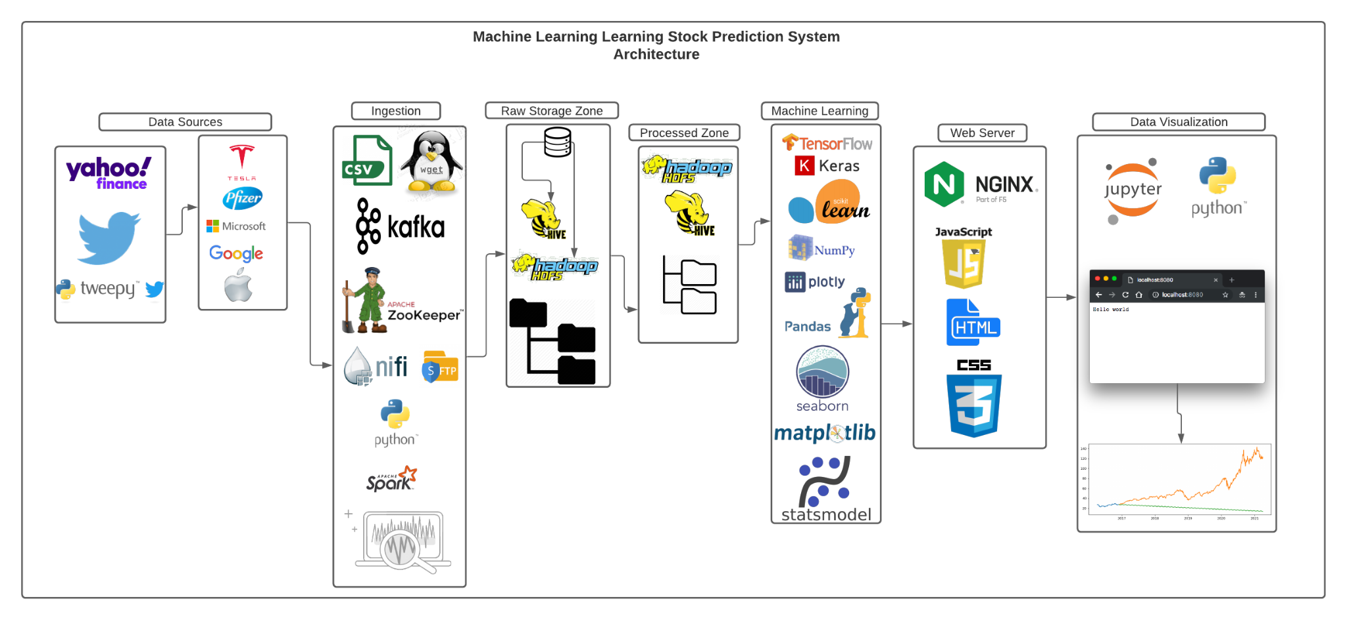

**Figure 1**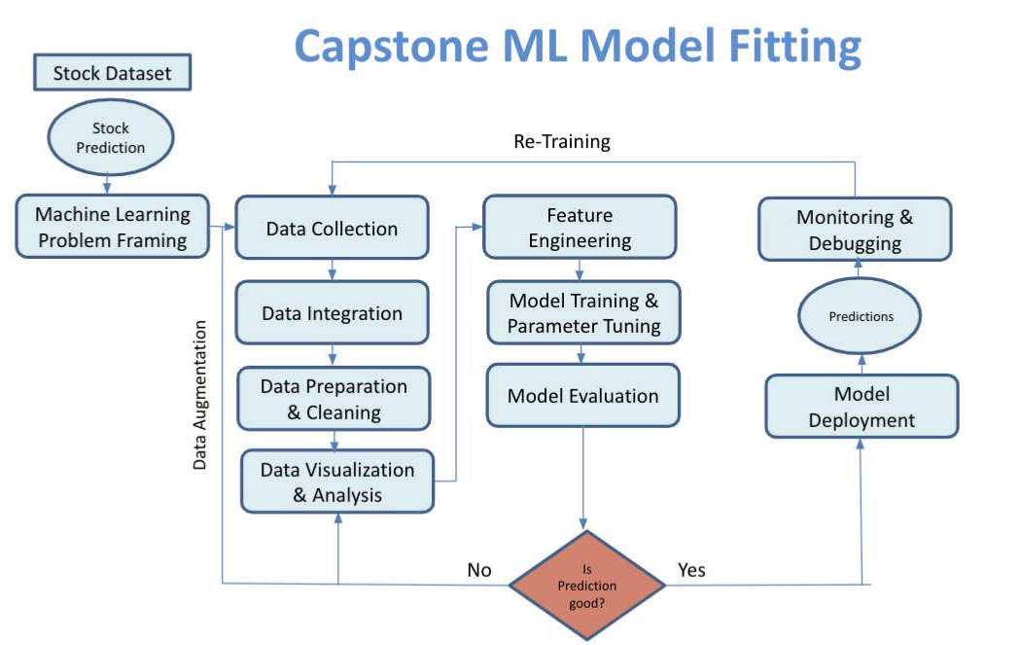

**Figure 2**

### System Architecture Processes Explained

**Figure 1 Explanation Process**

First let's explain **Figure 1**. First we will need to gather our data sources, we will use historical stock price data ranging from the high, low, and closing prices from the past 5 years using Yahoo Finance and get live time messages and tweets using Twitter showing the current trends of our selected companies. The companies selected are Tesla (TSLA), Pfizer (PFE), Microsoft (MSFT), Google (GOOG), and Apple (AAPL) because these are mostly safe choices to predict without much risk, except for TSLA. TSLA has been a quite wild one over the period, but it will be interesting to see what will happen. Finally, Tweepy is a free and open source library for accessing the Twitter API. It is a great solution for simple automation and creation of Twitter bots. We will use the Twitter API to search for live time tweets for our project use case.

The second part will mainly focus on the ingestion of our data, The beauty of this setup is that we don’t need high end servers or computer equipment to run all this, a simple laptop with a command line or terminal with a little bit of hard drive space is enough. In the first part of ingestion we used a Wget call command within our Jupyter notebook environment, this will help retrieve content from the Yahoo Finance web server for each individual stock data and then download it into a clean CSV data file. Everytime this wget command is called it will replace the old data with new data in our data repository and we can keep having the latest stock data. For the second part of ingestion we are going to use Kafka as a streamlistener to search and gather live tweets to visualize and see the live trends of what is happening with our companies and what other people on Twitter are talking about this specific company, this is useful for real time insights before purchase. Apache Zookeeper was installed before running the Kafka clusters, Zookeeper helps sync and coordinate multiple producer and consumer message queues, it can also perform simultaneous reads and writes for Twitter message queues via Kafka. In fact, many companies like Spotify, Slack, and Linkedin use this to manage their streams and message queues. Third, add Apache Nifi to extract, transform, and load all the company data to the Raw Storage Zone using SFTP (Simple File Transfer Protocol) to manually insert and load our data. Lastly, for enterprise usage we can use PySpark which is a subfolder of Apache Spark to run our Python code in-memory opposed onto the disk. This in theory can run on billions and trillions of data on distributed clusters 100 times faster than the traditional python console to achieve faster run time performance and time complexity and save data space.

For the third part we will combine and explain the transition from the raw storage zone to the processed zone. The Raw Storage Zone consists of Hive and Hadoop HDFS, this is where all collected data is stored and later processed to the process zone through a series of steps moving from one directory to another directory which is why we have a picture of multiple folders. This is also similar to another concept called Data Lake.

Now for the fourth part, after completion of all data engineering work, we can train, validate, and test our data to do machine learning. Figure 2 will go into higher detail of all the machine learning techniques and algorithms we used, but from this diagram we can take a look at all the tools, libraries, and packages used. Tensorflow and Keras are used to build and train various machine learning models like deep learning and different types of neural networks. Pandas will help cleanse the data into a clean readable data frame format. NumPy will be used to do the heavy lifting for the mathematical calculations like variance, square roots, and even logarithms. Scikit-learn and Statsmodels will be used hand in hand for statistical modeling including classifications, regressions, clustering, and time series prediction for our data. Both libraries will be used for model fitting through use of statistical analysis. Finally Plotly, MatplotLib, and Seaborn help us visualize our model into the Jupyter notebook through visualization plots and techniques like a heatmap or a line graph, using these libraries you can even change the color, plot types, and visualization methods in detail to make your work look pretty and cool. Since this was not a visualization project, we did not focus too much time on machine learning visualizations rather we spent our time trying to get good prediction results. There are many open source and free machine learning frameworks and libraries for anybody to test according to their needs for any kind of problem to solve or go after, it's a matter of trial and error and seeing what works. For example if you are looking for something in the fields of Natural Language Processing (NLP) or text analytics something like Pytorch or Natural Language Toolkit (NLTK) would better fit your needs. Keep in mind that all of these libraries, packages, and frameworks are 100% open source and free.

Coming on to part six, which is the final part. We now need to set up a web server to eventually visualize our final results. This part will serve as the front end while everything completed in the previous five parts are the back end of the project. Once our code is run from Python for the Twitter message queues and stock models, it will save into a Hadoop or Hive data repository or on your own local machine. We can then create a HTML file to call the stock model results and Twitter message queues into a table in our HTML code and everytime to the code is re-ran the HTML code will update accordingly and automatically to the new stock data of the week. In this part of the project it would be useful to have some basic knowledge of HTML, Cascading Styling Sheets, and Javascript to build a nice table to show our results, placing small captions for explanations, and have some color styling. Now to call and see our final work we will use an open source web server framework called Nginx, there are many other options like Apache Tomcat or HTTPD to make a web server call, But, Nginx seems to be pretty easy to install and it’s very lightweight, so it won’t use a lot of CPU or Memory power. Nginx is also pretty robust in features such as offering other services like load balancing, cloud integrations if needed, and finally it’s very secure as it also has reverse proxy capabilities to prevent unauthorized access to a web server. To call our final work, go to our computer terminal and configure the path of your application’s root directory and reference the HTML entry point as the index file. In our example, the root directory for the stocks deployment is /local/usr/var/www which contains all the files. The root directory also contains the index file, called index.html. Nginx serves the index file when visiting the configured domain. In this case, nginx serves the index.html when visiting our project. To serve just go to your browser and type 127.0.0.1:8080. NOTE: Nginx sets the default port to 8080, it is best recommended to go to nginx conf files via the computer terminal and change the default 8080 port to another port for security measures as hackers are prone to attack commonly used ports within a network. In my case, I changed the port to 8083. Once again, the beauty of this setup is that we don’t need high end servers or computers to run all this, a simple laptop with a command line or terminal with a little bit of hard drive space is enough.

If done correctly you should be able to see your work:

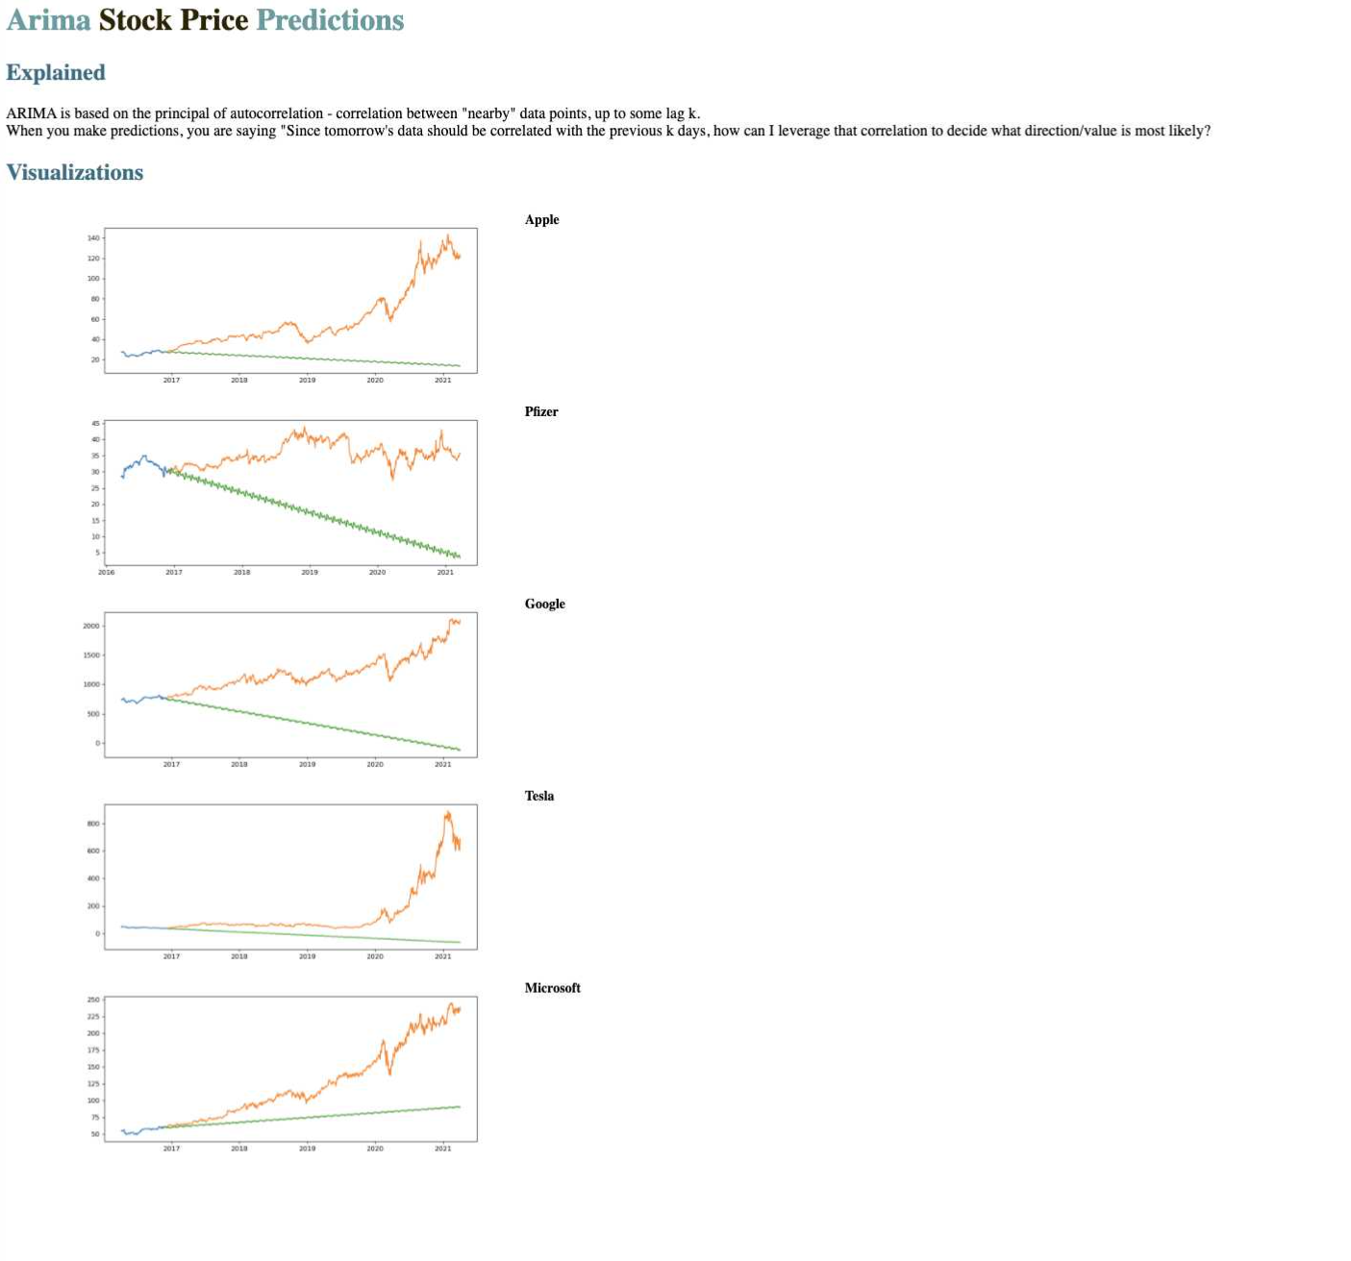

**Important notes**:

* The location property ensures to serve requested files if available. For unavailable files, nginx responds with the 404 HTTP status code.
* Ensure the root and index properties and nginx serves static HTML and JavaScript files.
* To see other files just call 127.0.0.1:8080 again but put 127.0.0.1:8080/”other.html” at the end.

**Figure 2 Explanation Process**

Now for Figure 2, we will go into higher detail of the Machine Learning concepts and how they are applied. First, we have already sorted our target problem and mapped it out, prepared, and cleansed our data properly as we explained in great detail in figure one. The four main machine learning concepts we used for this would feature engineering, time-series forecasting, model fitting, and deployment. Feature engineering will consist of features such as mean, median, mode, and even standard deviation. We can add various features like this to the data and drop it accordingly to need, then we can predict using this data. Actual existing data is difficult to predict and get good scoring models, so multiple features can help predict good scoring models. Second, for time series and forecasting, we chose (Long-Short Term Memory) LSTM for long term sequence prediction and ARIMA for short term prediction. The Kalman Filter will also be inserted along Kafka stream messages mentioned earlier to weed out any potential noise, outliers, and anomalies in the data. We will experiment with different machine learning models ranging from recurrent neural networks, convolutional neural networks, deep neural networks, artificial neural networks, and long-short term memory and see what works the best. The idea is to always test, train, and validate with various models and see what works best before deployment. Finally, as we see from the end of the diagram, we need to make a decision if our prediction was good enough or not and what variables need to be changed to get a better result. Its process of trial and error and seeing what works.

So you may wonder, how does this even work and how are the stock price results derived from. To explain this, we need to understand what time-series means. In simple terms, a time series is a sequence of observations measured at successive times, this can be monthly, trimestrial, or annual, sometimes weekly, daily, or hourly. In our case we will be using years of stock data from our selected companies from the past 1-5 years to predict the future prices. Next to go into higher detail, time series analysis is using methods that attempt to make predictions. This can be broken down into 4 parts, which we will use throughout our project. First, we have secular trends, this describes the movement along the current term. Second, seasonal variations will represent seasonal changes throughout the years. Third, cyclical fluctuations will correspond to periodical but not seasonal variations. Fourth, irregular variations are taken into account for other nonrandom sources of variations of series that could cause a potential outlier. As, we can see **time series forecasting** involves taking models fit on historical data and using them to predict future observations, except we have to tune, scale, and fit our models to a certain criteria to make good predictions. In the end we also had a trend line to our end model to show the pivot highs or under pivot lows to show the prevailing direction of price.

There are various time series machine learning models we can try and implement to predict future stock prices. Some of these include **Long Short Term Memory (LSTM)**, **Autoregressive Integrated Moving Average (ARIMA)**, **Prophet**, and **Bayesian Structural Time Series (BSTS)**. LSTM uses time-series forecasting to predict the future sequence pattern from using historical data of stock prices, they are very powerful in sequence prediction problems because they're able to store past information. ARIMA is based on the principle of autocorrelation - correlation between "nearby" data points, up to some lag k. Think of it like this: when you make predictions, you are saying "Since tomorrow's data should be correlated with the previous k days, how can I leverage that correlation to decide what direction/value is most likely? Prophet, is a source library created by **Facebook** that is based on decomposable (trends+seasonality+holidays) models. It provides us with the ability to make time series predictions with good accuracy using parameter passing. Lastly, BSTS is used feature selection, time series forecasting, nowcasting, inferring causal impact for time series based data.

Most time series data we described above use concept neural networks throughout their deployment. Think of it like this: The neural network is used when you want to recognize patterns. You have to know the patterns you want to find ahead of time. This is called "supervised learning.". Neural nets are bascially simplified models of brains. In a brain, you have neurons, which are either activated or inactivated, and synapses, which connect the neurons together. The neurons are represented as simple booleans or in computer science also known as nodes, and the synapses are represented by generally small numbers between negative one and one. Next, LSTM is an example of **recurrent neural networks (RNNs)**. These come into play because traditional neural networks can not really predict from history. For example, think of what you want to classify what kind of event is happening at every point in a movie or a game. It’s pretty unclear how a traditional neural network could use its reasoning about previous events in the film or game to inform later ones. Recurrent neural networks address this issue. They are networks with loops in them, allowing information to persist as time keeps going, so they can predict what happens in the future or take another path if needed. This same methodology will be applied when studying our company stocks. Other types of nueral networks include **convolutional neural networks:** These separate the input into "receptive fields' ' and are very powerful for image processing. Basically, here the input is separated into areas. The first layers focus on lower level features. EX. there's a circular structure here, etc, while later layers look at higher level features: this is a nose, this is an eye. **Deep neural network** (DNN) is an artificial **neural network** (ANN) with multiple layers between the input and output layers. There are different types of **neural networks** but they usually always consist of the same components. Lastly, we have **Generative Adversarial Networks:** involve two networks "fighting" each other. One generates things like images or data sets, and the other tells whether the generated work is fake or not. They both train at the same level with the generator trying to fool the discriminator, and the discriminator trying to catch the fake or wrong data using various classification methods.

In the end you have to try out each one and pick one or two that works best for you and stick to that. Picking a model that works best for you and building one can take some time, so patience is an important skill. For this project, we have chosen LSTM and ARIMA to predict our stock prices and we will show our results and findings in the next section.

Before we show the results we need to fit our model. We need to fit (protect against underfitting) and cross validate it (protect against overfitting) also known as k-fold validation. Basically, doing this makes our models stay "valid" over time, but as new data becomes available they don't remain the best model out of all our options. You need to think: Is it worth the extra overhead to change models week over week? Finally, we also normalize the input features/variables using the Min-Max scaler. By doing this, all features will be transformed into the range [0,1] meaning that the minimum and maximum value of a feature/variable is going to be 0 and 1. This is useful in cases where all parameters need to have the same positive scale and making sure outliers from the data set are taken out. After all this we can train and deploy our model and see what we get.

# Results

## Arima Results

After a long awaited time, here are our results, we will start with the Arima model first. This will predict the short term over the 5 years worth of data.

Legend:

* Green: Trend Line
* Orange: Validated/Predicted Data
* Blue: Train Data

Apple **ARIMA**

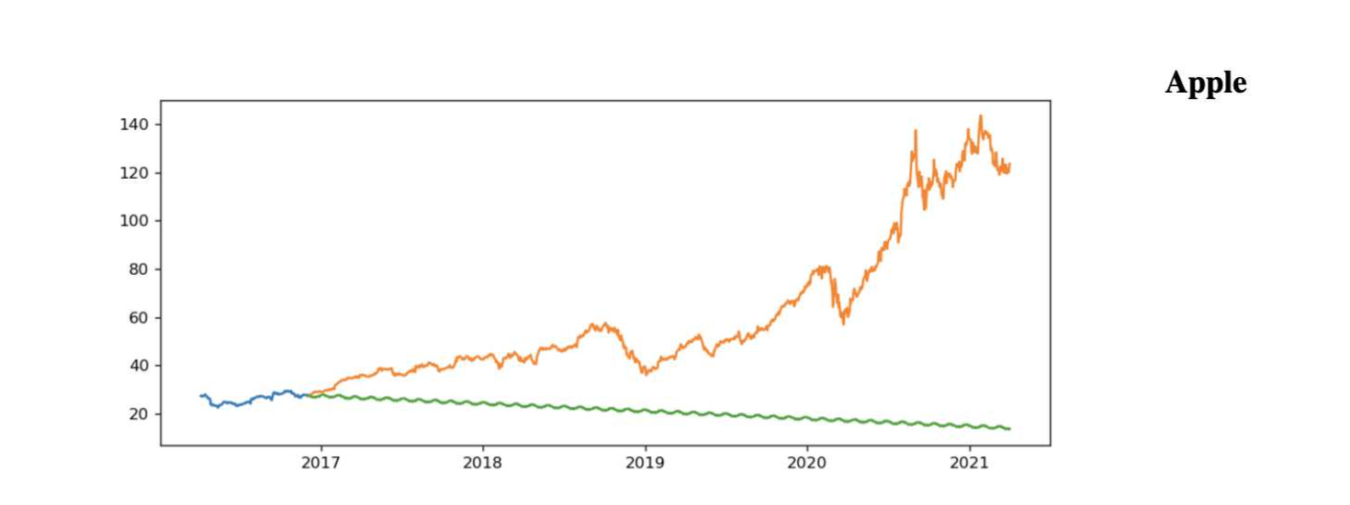

Pfizer **ARIMA**

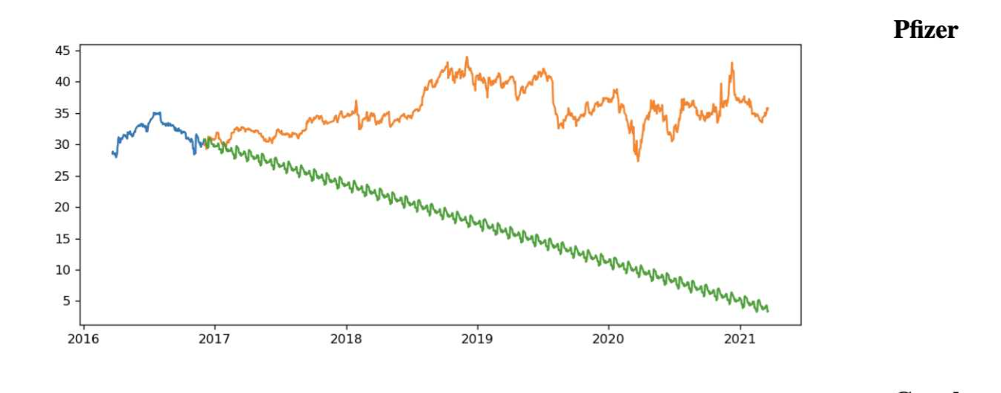

Google **ARIMA**

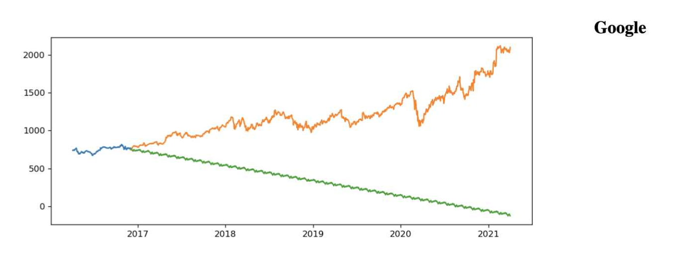

Tesla **ARIMA**

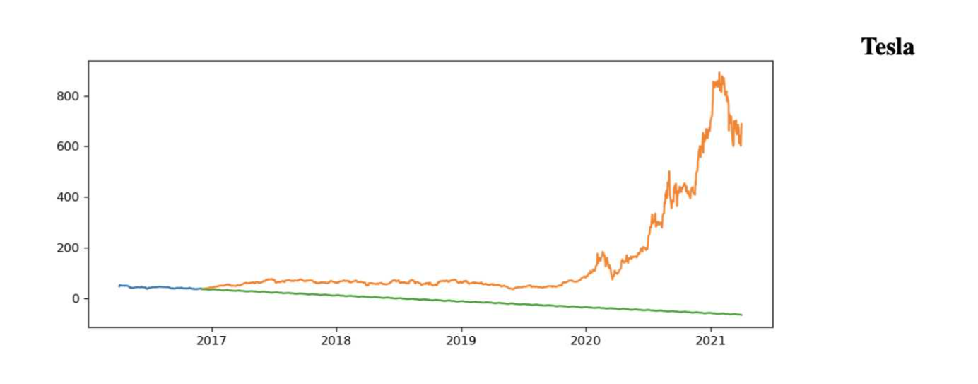

Microsoft **ARIMA**

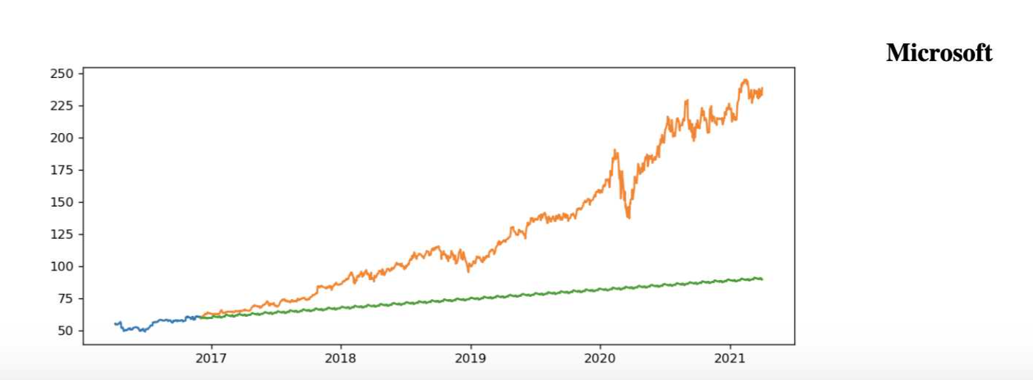

Full Visualization of Arima Models using Nginx web server call and HTML design



### LSTM Results:

The blue is the train data, red is validated data, and yellow is predictions.

Apple **LSTM**

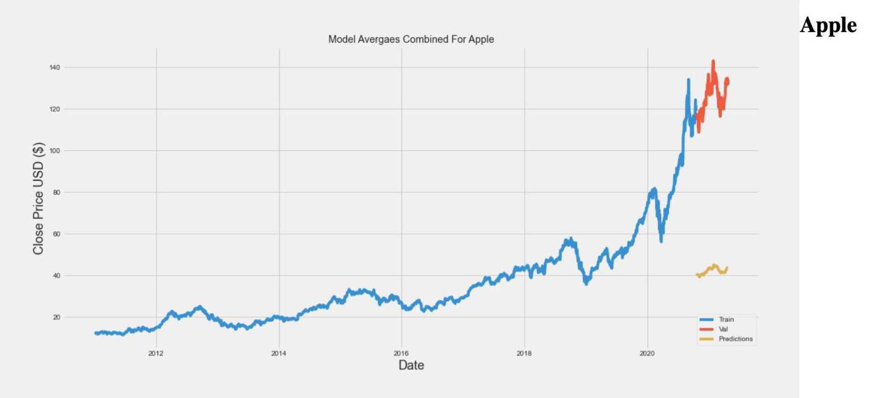

Pfizer **LSTM**

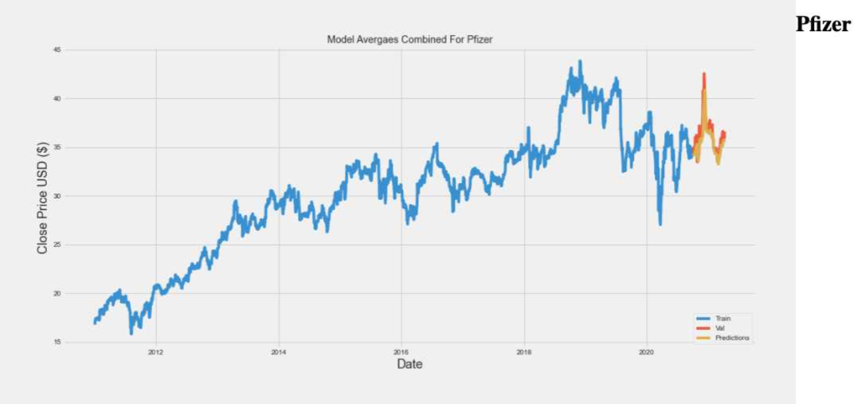

Tesla **LSTM**

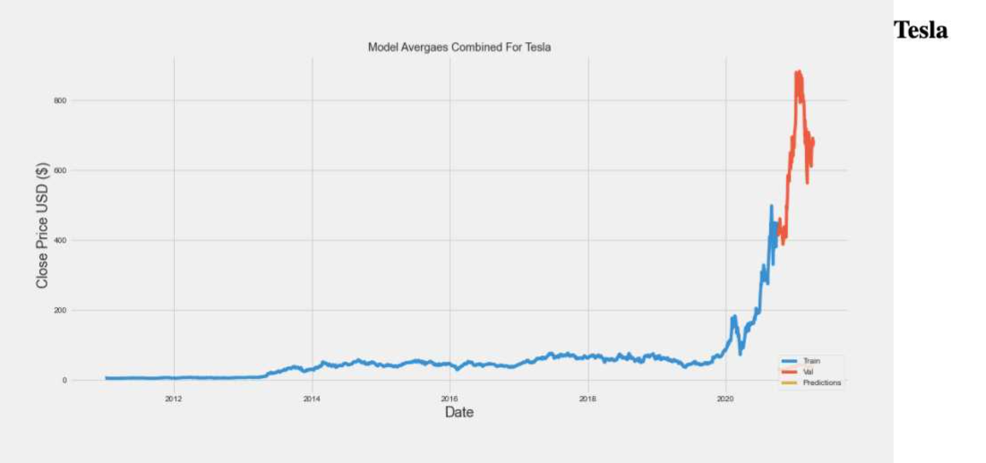

Microsoft **LSTM**

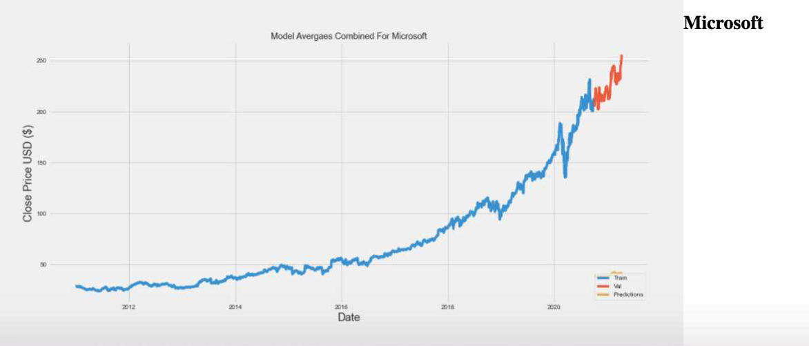

Full Visualization of **LSTM** Models using Nginx web server call and HTML design

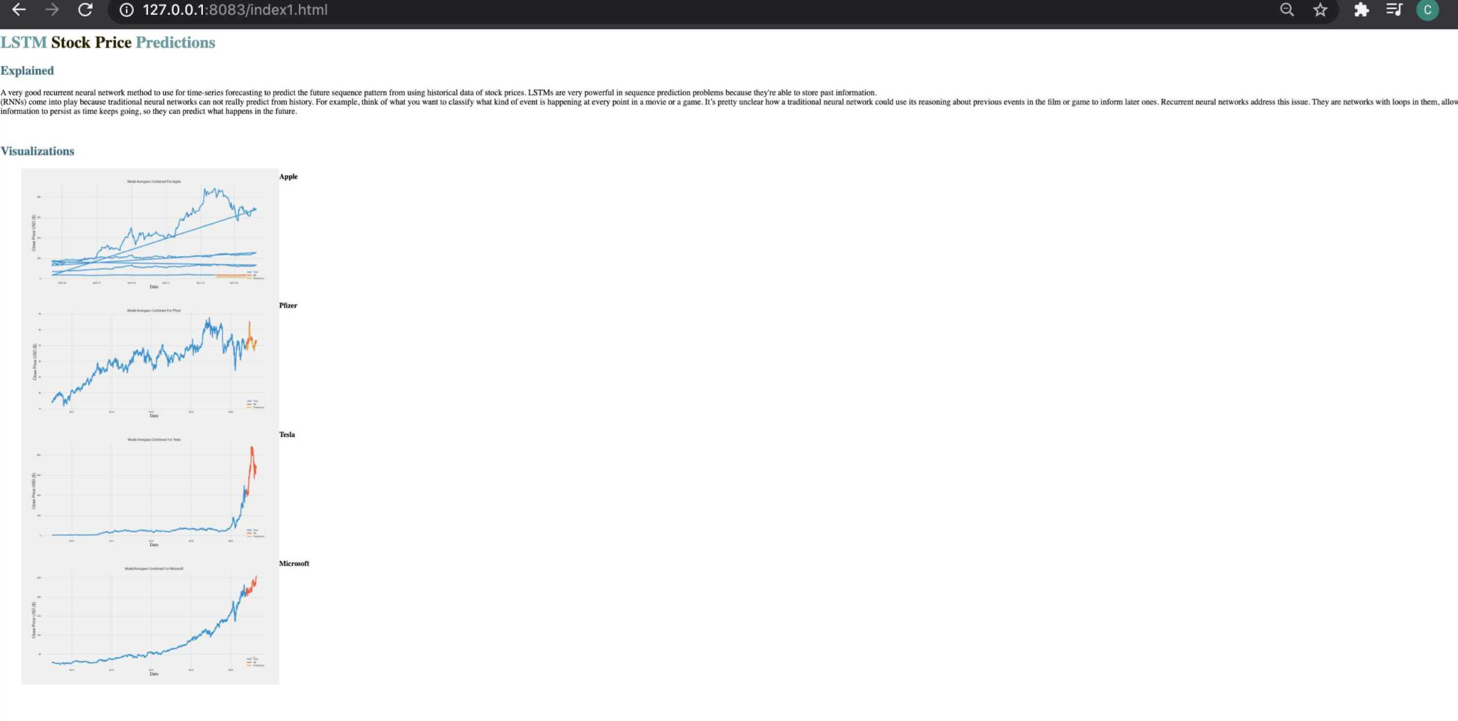

#### Kafka & Back End Results

Figure 2.1: Sample Kafka Logs for Live Tesla Stock Twitter Tweets for April 7th 2021. Table shows Kafka Logs for Date and Time tweeted along with Tweet. There are hundreds of logs for each company, but here is a sample to not overflow the writing.

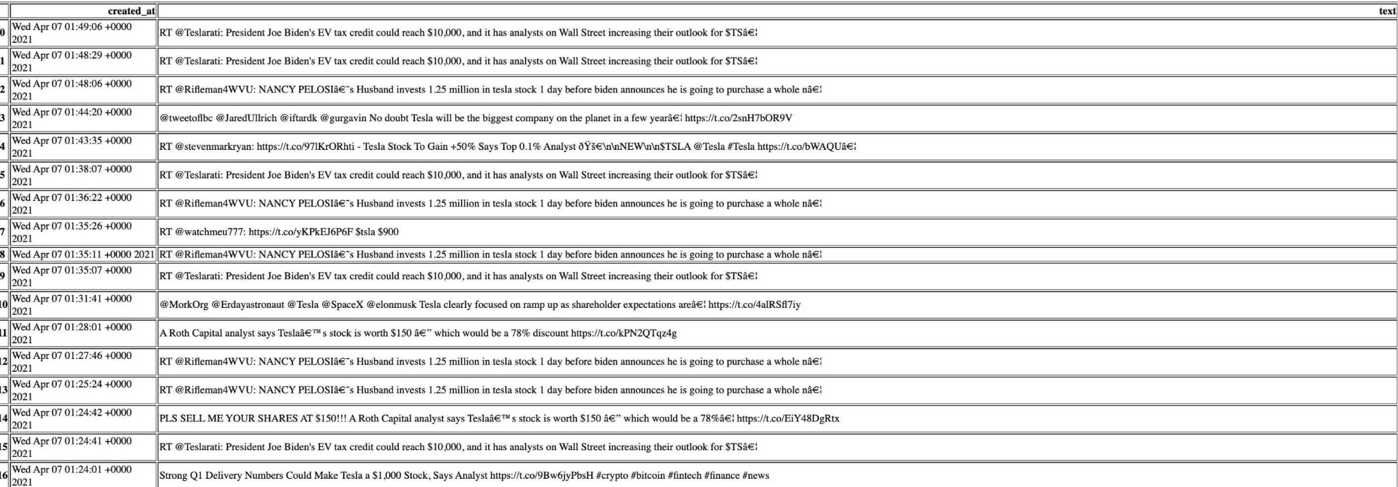

Figure 2.2: Backend storage of all files from kafka and stock csv predicted using Hadoop HDFS via Computer Terminal. You can use Apache Hue if you want to see your storage with a GUI Interface: <https://gethue.com/>

## 

Figure 2.3: This shows Apache NIFI on localhost:8080 using SFTP protocol to get and put files to complete our ETL process. This also runs in the backend with Hadoop HDFS. NIFI is a GUI based solution for backend ETL alongside Hadoop.

## 

Figure 2.4: Starting Nginx in terminal to view our project. Figures 1.5 and 2.0 show the full results of visualizations based in the browser.

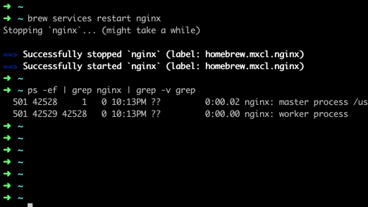

# Conclusion

This was a very extensive and tedious process. We were able to successfully build out both our front and back end. Our code ran without issues, the Nginx web server perfectly ran the visualization results, Kafka was able to output live Twitter logs for our companies, and finally we were able to store our data successfully into Hadoop HDFS and complete the backend ETL using SFTP with Nifi. The beauty of this setup is that we don’t need high end servers or computer equipment to run all this, a simple laptop with a command line or terminal with a little bit of hard drive space is enough. This is a cost saving.

Now speaking of the stock price prediction results, we were able to get some good results by taking our predicted prices and plotting it into a time series graph to see the up or down trend. The actual predicted numbers can be viewed on the full code uploaded to github om the attached documents page. From the visualizations we can see that Tesla is not a good buy as it would experience a big dip when tested both with LSTM and Arima. However, from the other side Pfizer, Google, and Microsoft when run with both models seemed pretty safe buys as they looked to have steady growth for the projected year as both models got pretty close together in terms of results. One big problem with Apple was it was all over the place and didn’t seem to have a clear picture with LSTM as we could see. This was kind of expected as some models may not run work perfectly on some stock data sets and sometimes we may have to change the years of going back and forth, like a 3 year analysis instead of 4 analysis of historical data could make a difference and in many cases we need to try with other time series models instead and see what happens instead. However, from past judgement we could assume that Apple stock price will proactively go up throughout the year as they are coming out with some new product releases.

We can also safely conclude that ARIMA yields better results in forecasting short term, whereas LSTM yields better results for long term modeling based from a 5 year period of historical data which we did in our project. This is mainly because very few actual problems are structured so that the past realization provides much meaningful information about the future. Let's say you want to predict something like unemployment levels which sort of uses a similar process to stock prediction. This would depend on lots of data, and only minimally on past performance. Now, of course, we can learn what the size of normal moves are in any time period, and adjust for the current level. So a relatively simple ARIMA model will probably be 'best' because the problem is ill posed as there is insufficient information in the system, so you basically do best by predicting some sensible 'average' move. To conclude, another point to note is that Classical methods are also worth trying as Facebook’s Prophet is worth if you need to account for things like holidays. It’s often used in production in large firms.

Finally, the Kafka and Twitter logs were a completely optional part of the project. I decided to bring this in as it can give the user a little insight and live time report of what is happening with the company and also its stock price before making a purchase at the last minute. This is a safety measure. In future reference companies can also forward this Twitter logs and messages queues to Elasticsearch or Apache Solr and make sentiments of this data for market research purposes, but this would be a whole another project on its own. Finally, inserting a Kalman filter for these queues was a good method for noise reduction to get rid of potential outlier tweets that did not have much value to current trends.

Now, the big question everybody will ask is: can you use Machine Learning to invest in the stock market? Well, that depends on a number of factors beyond the stock market. The model you create, how you gathered and processed your data, and how your actual trading strategy interacts with it are all much more important than the market externalities itself. A machine learning engineer in theory should really know to create models which are general enough for their use case. That means making sure the data they use is representative of statistically likely situations from which the machine learning model can generalize as we did to the best in this project. At the end of the day as I mentioned earlier in this project, this is still not a full proof way because of outliers in past histories or unpredictable outcomes like black-swan (extreme events) in the stock market and also the stock market can be extremely volatile at times and that investing into the stock market is a game of risk and reward. Anybody wanting to make investments should always proceed with caution and should also know that they are solely responsible and liable for any good or bad outcomes that happen to them.

# Attached Documents

GitHub Link for code, logs, and documentation: <https://github.com/Pravinraja/IT489-StockPricePrediction_Short_Long_Term_Machine-Learning>

Code Highlights of Project

This code shows the explanations and the imports of all the Python packages for the Arima Model

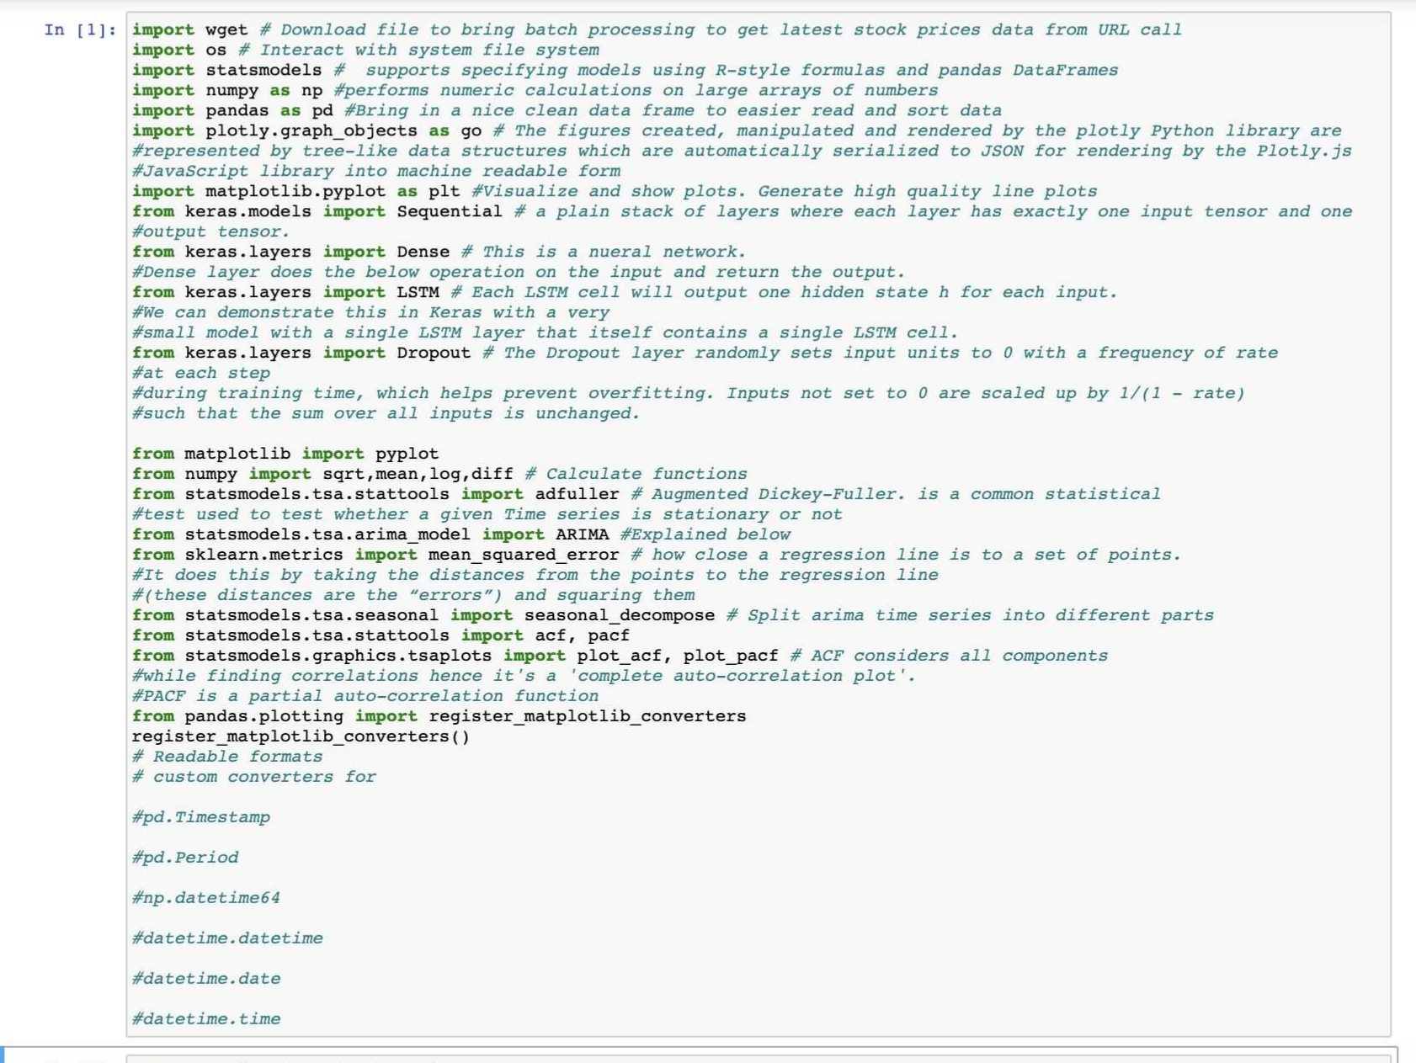

This below shows us imported the arima library and also using wget to bring our data from Yahoo Finance to train our early csv data.

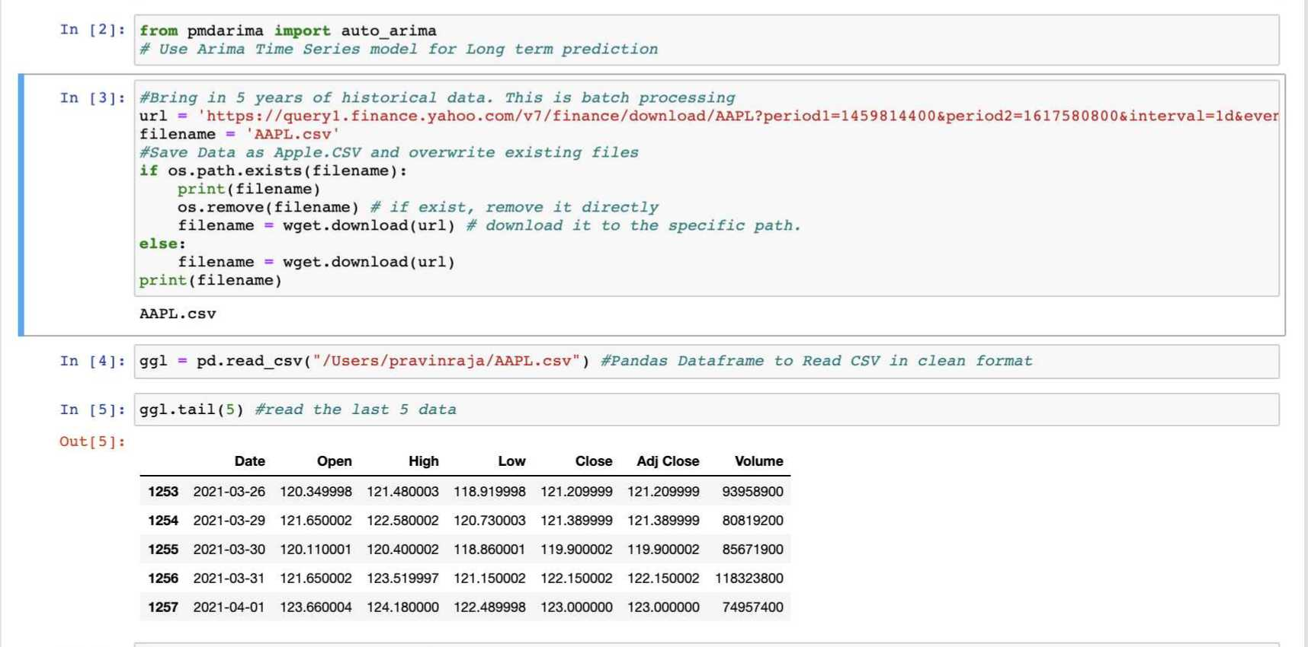

This code below shows us preparing the time-series visualization range slider for Arima

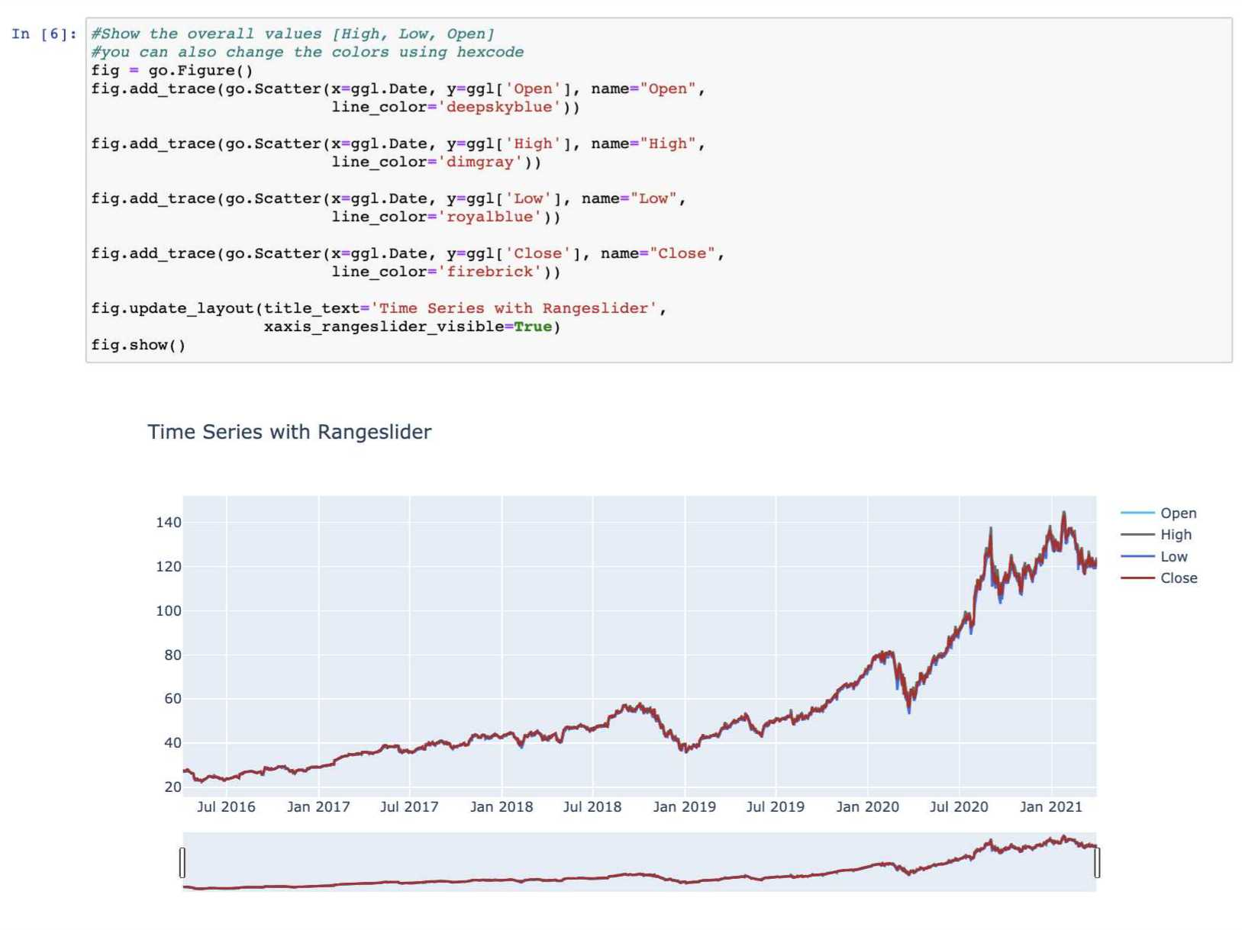

This code below shows performing the autocorrelation to take account for lag in the Arima model

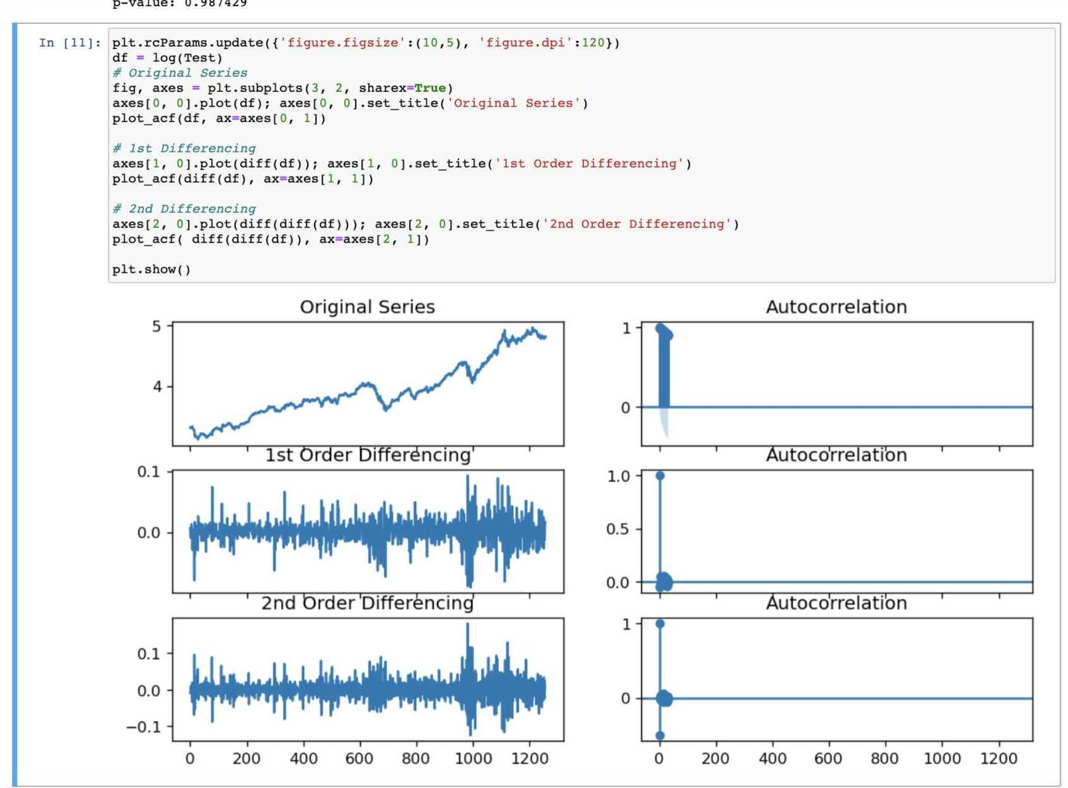

Preparation of early CSV Stock data for LSTM Model

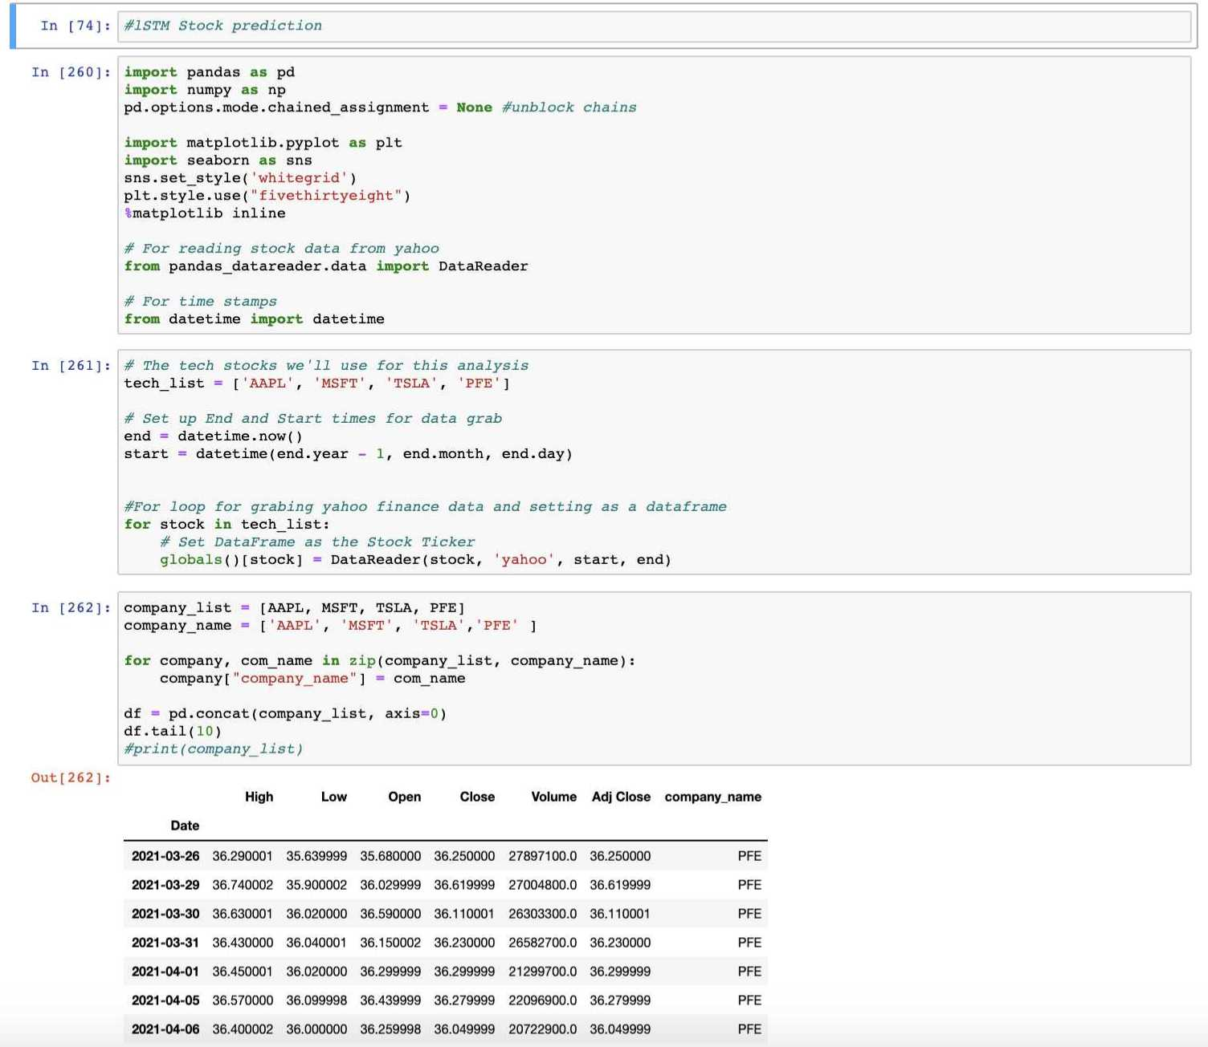

Setting up SubPlot visualizations for LSTM using coordinates

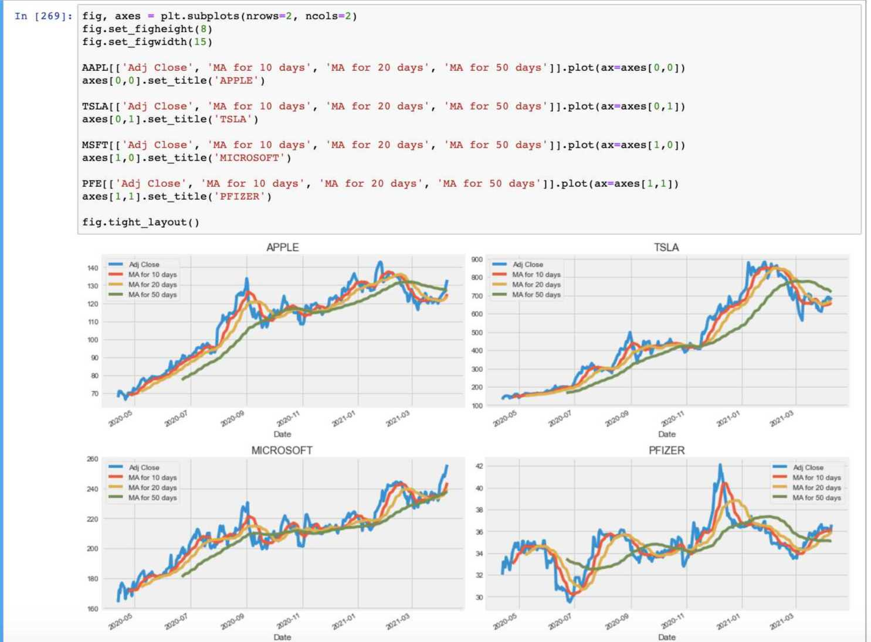

Bringing in stock quote data for LSTM using Pandas Dataframe

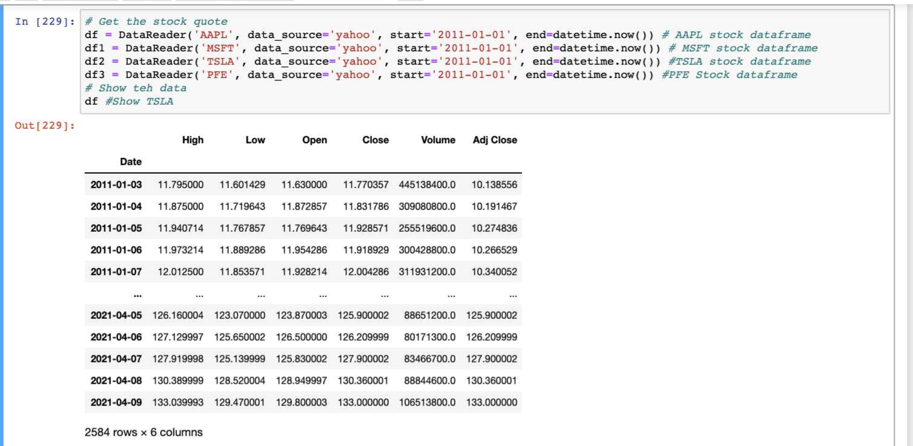

Actual Predicted stock prices for Microsoft LSTM prediction. This was later converted into a visualization graph and shown earlier in the results section.

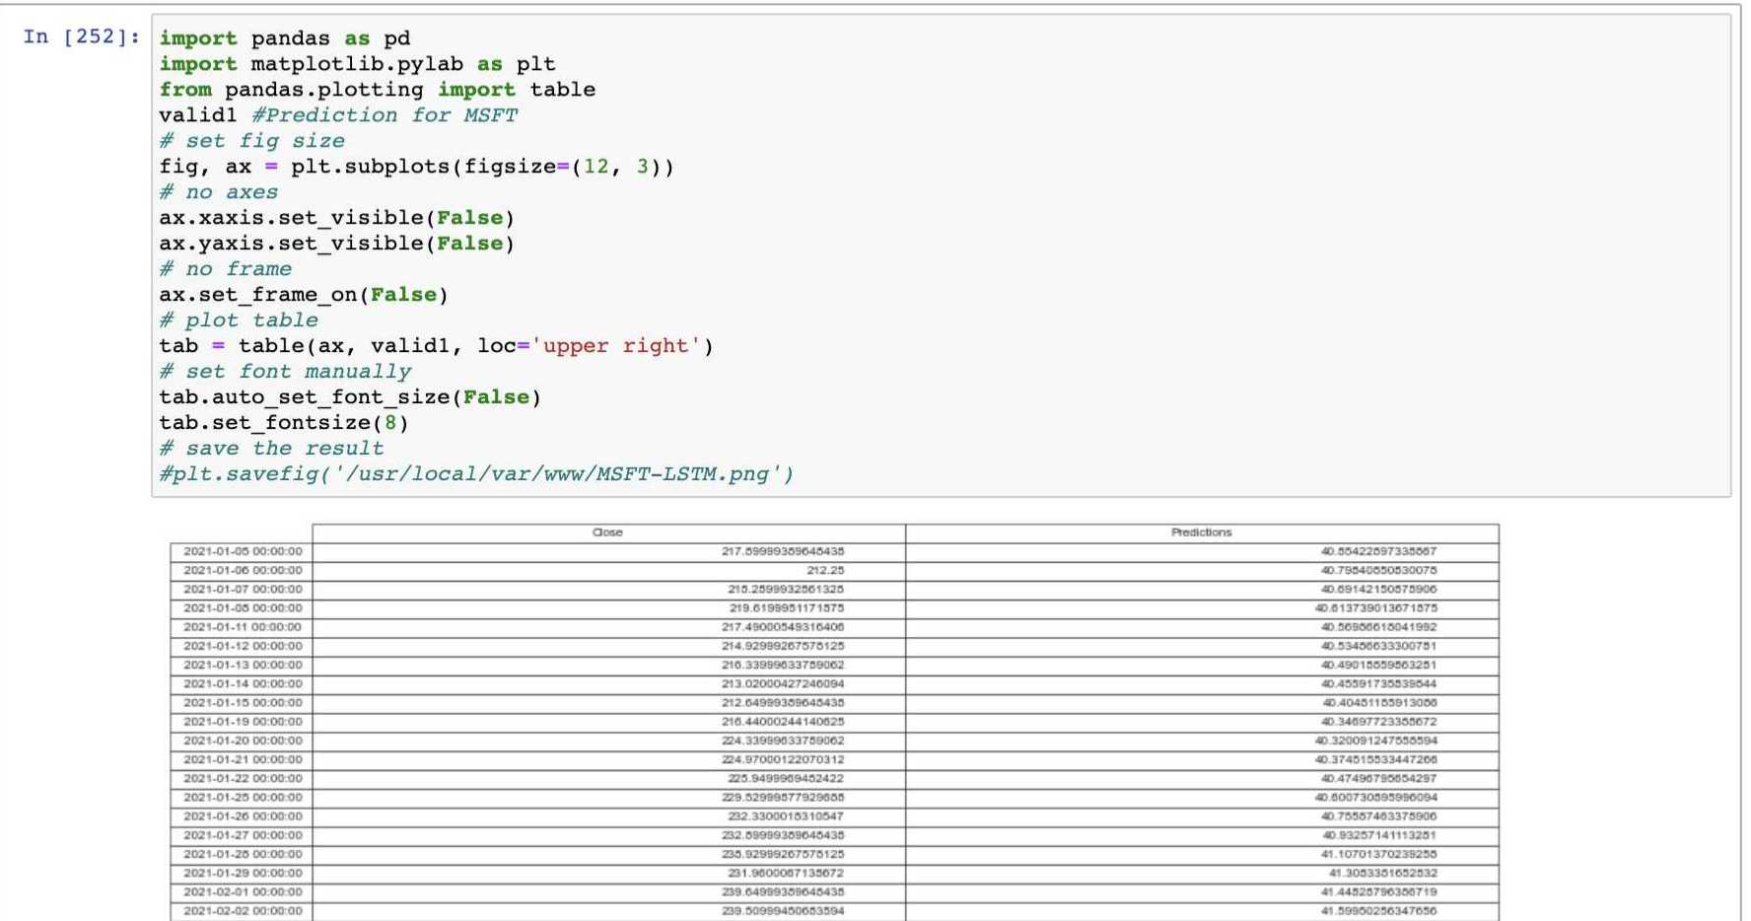

Next two snapshots below show Twitter, Tweepy, and Kafka Integrations for message queuing through stream listeners . **NOTE**: Twitter security credentials are censored out for security reasons.

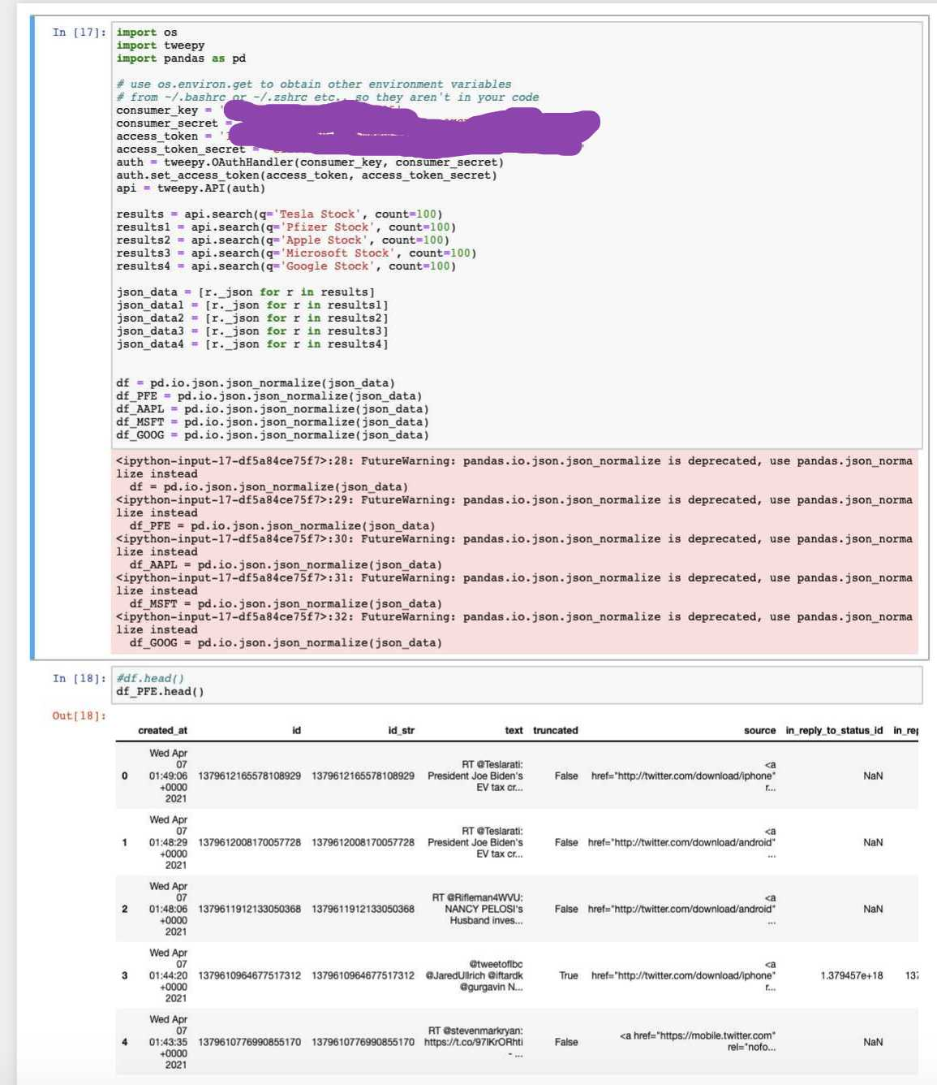

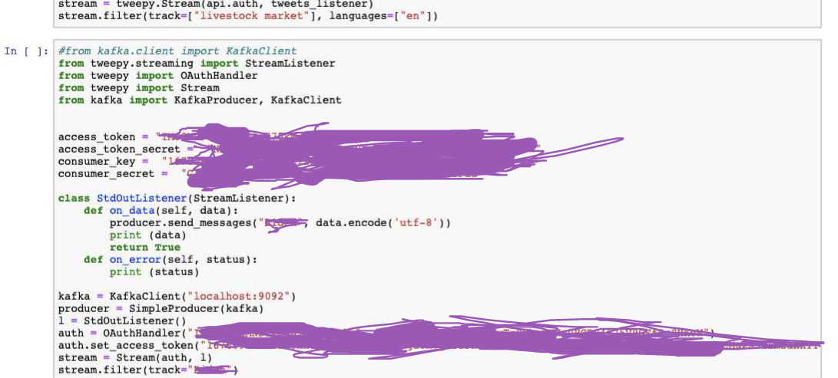

This part shows the HTML layout for Arima. Similar concept was used for LSTM webpage as well.

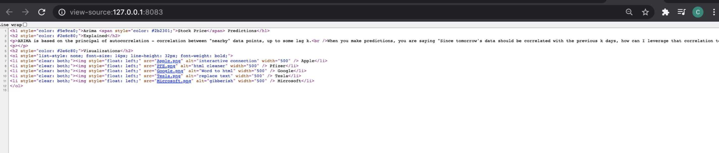

# Project Tools Used

1. Compute Resources

* Mac OSX or Linux Terminal
* Brew Package Installer: <https://brew.sh/>

1. Storage Resources

* Hadoop Distributed File System (HDFS): <https://hadoop.apache.org/releases.html>
* Hive Database: <https://hive.apache.org/downloads.html>

1. ETL Resources

* Apache Spark Streaming: <https://spark.apache.org/downloads.html>
* Pyspark
* Apache Nifi: <http://nifi.apache.org/download.html>
* Pandas Dataframe: <https://pandas.pydata.org/pandas-docs/stable/reference/frame.html>

1. Messaging Resources

* Apache Kafka: <https://kafka.apache.org/downloads>
* Apache Zookeeper: Synchronous with Kafka Installation

1. Scripting Languages and Imported Packages from PIP Installation

* Python, Pyspark
* Jupyter Notebook
* Wget
* Tensorflow
* Keras
* MatPlotlib
* Plotly
* Statsmodels
* NumPy
* Seaborn
* Tweepy
* Scikit-Learn
* Frequently updated and changed based on model requirements

1. Visualization & Web Server

* Nginx: <https://nginx.org/en/download.html>
* Visual Studio Code ++ for HTML, CSS, Javascript: <https://code.visualstudio.com/>

1. Data Sources

* Yahoo Finance Historical Data (<https://finance.yahoo.com/> )
* Tweepy to access Twitter API: <https://www.tweepy.org/>
* Twitter Developer Portal: <https://developer.twitter.com/en/apps>

1. Architecture Diagrams

* Lucidchart

**Overall cost**: 100% Free and mostly open source using local mac or linux terminal

Credit and License to Apache Software Foundation and all their work for the open source community: <https://www.apache.org/licenses/>

<https://www.apache.org/foundation/policies/conduct>

# Bibliography

Pöhls on October 24 2019, Marcus. “Nginx - How to Serve a Static HTML Page.” *Future Studio*, 24 Oct. 2019, futurestud.io/tutorials/nginx-how-to-serve-a-static-html-page.

5, July, and Walker Rowe. “Working with Streaming Twitter Data Using Kafka.” *BMC Blogs*, BMC Corporation, 5 July 2017, www.bmc.com/blogs/working-streaming-twitter-data-using-kafka/.

# Final Documentation

**Expected Outcomes**: We should be able to predict stock prices in the future for well known publicly traded companies. The end result should be in a HTTPS web URL format which we can visualize using Nginx. This is after running the model and the score of this model should be stored in a web URL alongside showing our gathered Tweets with Kafka queues.

Although not used in this project, Apache Airflow can be brought in to schedule and automatically run every Python job in the background, this is very useful in enterprise applications and production environments. In this project, the jobs will be run manually. Also, for future and enterprise use we can containerize all our work and package it into a Docker container and deploy using it Kubernetes, so in the need we need to share and give the work to someone else on another computer they don’t have to go through and install all the packages themselves or come into any errors when trying to run our work or project. This would help with developing shipping, and running applications much faster and easier. Finally, Apache Hue could be added to get a GUI solution to see our data storage and Apache Solr could be used to search through Kafka Logs for future reference.

**Knowledge Being Applied**: Useful courses in Marymount for this course were Python Programming (IT-229), Structures of Programming Languages (IT-320), Data Structures and Algorithms (IT340), Database Technology (IT-310), Statistical Analysis (MA-132), Computer Networking (IT-305), Web Development (IT-125), and an optional course in either micro or macro economics (ECO-210).

The first three courses listed go deep into the Python programming language gaining you skills in writing clean code, the in-depth knowledge of language itself with concepts like time complexity, storage, parameter passing, and recursion, and working with multiple libraries and packages. Next, Database Technology is important because it goes over concepts like storing and maintenance of data records. Third, a math course like Statistical Analysis would be helpful because it goes over high level concepts in identifying patterns and trends in data sets which would be useful to analyze and write code for our project while also learning how to compute mathematical equations. Computer networking is also useful because it tells you the basics of network infrastructures, internet protocols, and securing & deploying network ports to deploy web servers correctly. Web Development gives us a good introduction into Website creation and design for front end applications to improve end user experience while the other courses help us create the back end of the project. Finally a course either macro or micro economics would be useful because it gives us a high level understanding of international business and market trends that affect our daily lives.

In the end of the day the student will be able to traverse and learn machine learning, data and financial engineering skills by working with concepts like ETL (Extract, Transform, and Load), data processing and cleansing, visualization, message queuing, financial modeling, implementing frameworks and algorithms, and model fitting. Finally, the student will gain knowledge on setting up the right test environments along with using outside internet resources to solve any issues or roadblocks they come across or knowledge not learned inside the classroom.

**Risk Factors:** The main risk factor is not being able to finish on time as this is a very challenging project going through complex technical concepts, most companies would distribute a lot of these tasks and hire a separate person for each task. Another risk factor would be running into any implementation or code errors as this is very common in the field of data engineering. Finally, as mentioned above predicting stocks is risky and not always accurate in many situations, although this project tries to take in account for most of these situations, it is still not always 100% accurate.

**Work to be performed by others**: As of now, everything in this project is done by me solely and through the help of various internet sources ranging from Coursera, Youtube, Apache software documentations to compile a complex project with many requirements and tools. StackOverflow will also be used to help debug issues throughout the way.